User testing
For the user testing we will focus on 3 things: UX, usability and functionality. To measure this, we will first spend 2-3 minutes briefing the player on what they should focus on and roughly how to play. Then we will ask the player to play through the current demo for 10 minutes while observing their actions. During these 10 minutes we will give them a specific objective of completing orders successfully, failing an order and purchasing upgrades in the hub. Any observations we deem important will be noted down, these could be places where players were confused, where there was hesitation, any features that were ignored or if they encounter a bug. Finally, we would ask the player to complete a short interview and survey to assess their experience playing the game and to determine any specific feedback that they might have.

Section | Question | Type | Metric/ scale | Data collected | Purpose
UX | I felt engaged while playing. | Likert | 1-5 | Rating | Measures engagement
UX | How did the game feel overall? | Open-ended | N/A | Text | Understand emotional experience
Usability | The controls were easy to use. | Likert | 1-5 | Rating | Evaluate control clarity
Usability | Did you ever feel confused? | Open-ended | N/A | Text | Identify usability issues
Functionality | Systems worked as expected. | Likert | 1-5 | Rating | Check reliability of systems
Functionality | Number of failed orders. | Quantitative | N/A | Number | Measure difficulty/ balance
Game loop | Did you want to keep playing? | Likert | 1-5 | Rating | Evaluate loop engagement
Observation | Time to complete first order. | Quantitative | Seconds | Time | Measure learning curve.
Observation | Hesitation or confusion from player. | Open-ended | N/A | Text | Find any points that need to be clearer
Observation | Any bugs encountered. | Open-ended | N/A | Text | Find bugs to be fixed that were missed

Raw data

Question 1 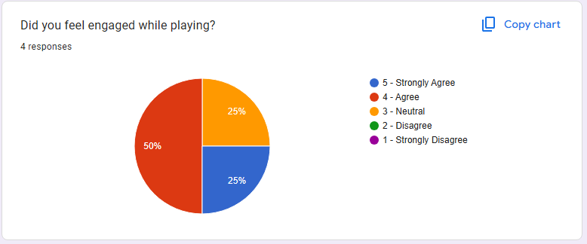
Question2
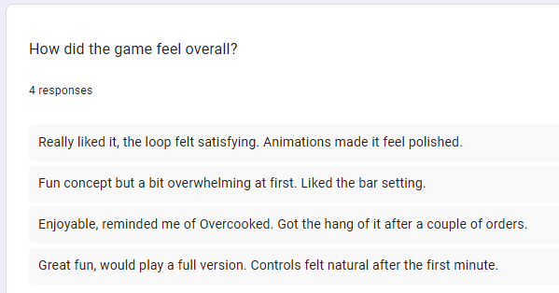
Question 3
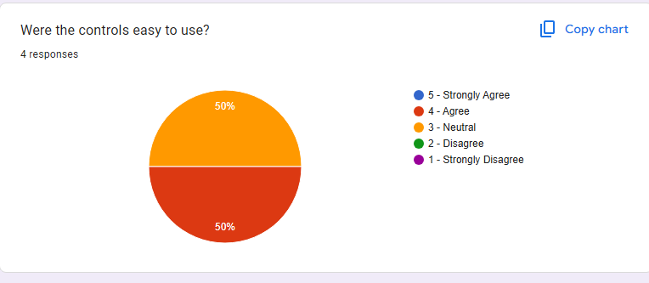

Question 4
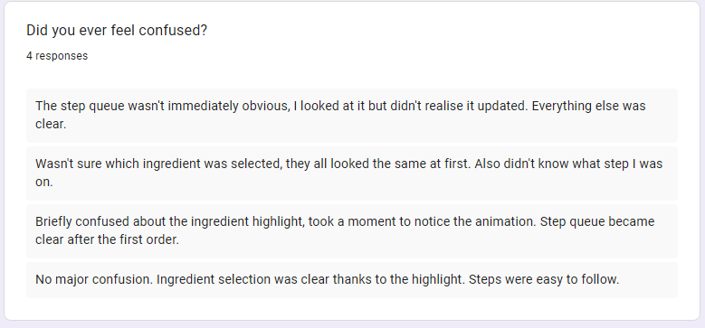
Question 5
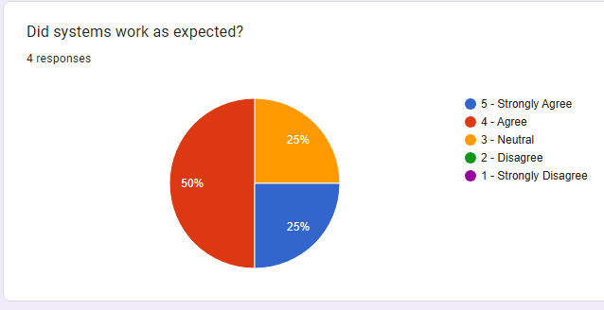
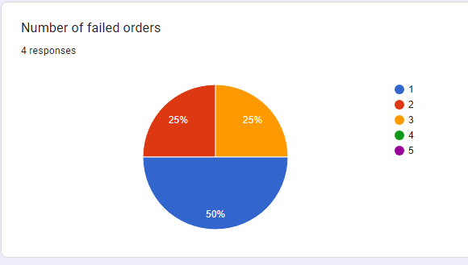
Question 6

Question 7
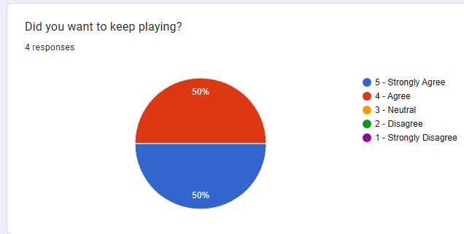
Question 8
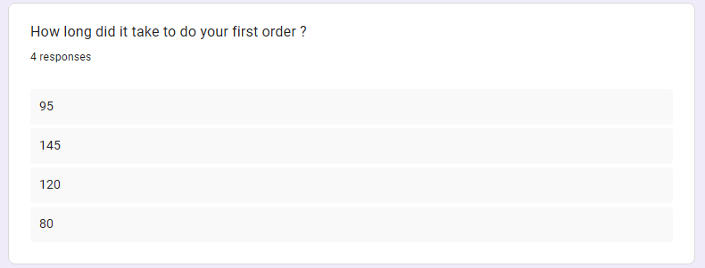
Question 9
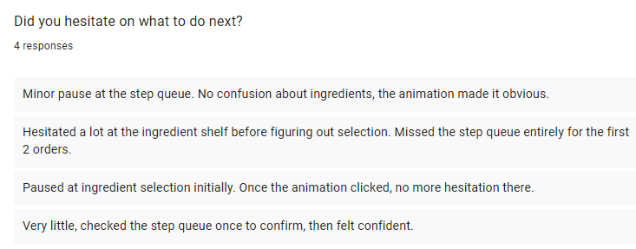

Question 10
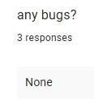

Likert Survey review
Participant | Engagement | Controls easy | Systems worked | Wanted to keep playing
P! | 3 | 3 | 3 | 4
P2 | 4 | 3 | 4 | 4
P3 | 4 | 4 | 4 | 5
P4 | 5 | 4 | 5 | 5
AVG | 4.0 | 3.5 | 4.0 | 4.5

Quantitative metrics
Participant | Time to first order (s) | Failed orders
P1 | 95 | 2
P2 | 145 | 3
P3 | 120 | 1
P4 | 80 | 1
AVG | 102.5 | 1.75

Open-Ended Responses
Participant | How did the game feel overall? | Did you ever feel confused? | Hesitation / confusion observed | Bugs
P1 | Fun concept but a bit overwhelming at first. Liked the bar setting. | Wasn't sure which ingredient was selected, they all looked the same at first. Also didn't know what step I was on. | Hesitated a lot at the ingredient shelf before figuring out selection. Missed the step queue entirely for the first 2 orders. | None
P2 | Enjoyable, reminded me of Overcooked. Got the hang of it after a couple of orders. | Briefly confused about the ingredient highlight, took a moment to notice the animation. | Paused at ingredient selection initially. Once the animation clicked, no more hesitation there. | None
P3 | Really liked it, the loop felt satisfying. Animations made it feel polished. | The step queue wasn't immediately obvious, I looked at it but didn't realise it updated. Everything else was clear. | Minor pause at the step queue. No confusion about ingredients, the animation made it obvious. | None
P4 | Great fun would play a full version. Controls felt natural after the first minute. | No major confusion. Ingredient selection was clear thanks to the highlight. Steps were easy to follow. | Very little, checked the step queue once to confirm, then felt confident. | None

Analysis
Lowest marks went to controls, averaging just 3.5 out of 5, newcomers might fumble at first. Though engagement hit 4.0, it wasn’t the standout. Systems held steady, also rated 4.0, showing few hiccups behind the scenes. What pulled scores up? A strong 4.5 on wanting to return, proving the cycle hooks once past early stumbles.

P2 struggled most when measured by numbers, first order took 145 seconds, worst of all, plus three attempts ended wrong. That lines up with what they said: unclear animations tripped them up, same with the sequence display. Not far behind, P1 jumped in faster, needing only 95 seconds, yet two tries still went off track, mixing up ingredients likely played a part, though speed wasn’t the problem. Only one mistake showed up for P3, even better, P4 made just a single error while finishing fast, clocked at 80 seconds flat, showing sharp grasp of how things worked. On average, failures came out to 1.75 per person, the ones who tested after early rounds handled steps and item choices more smoothly, clearly helped by tweaks seen on screen.
Actions taken
- Ingredient selection confusion – A small motion now draws attention to whatever ingredient is picked. Right away, both P3 and P4 moved straight to choosing without pause. Then came smoother decisions.
- Step progress confusion - Now showing steps in order on screen helps people track progress. Three of four testers caught on fast, spotting done versus pending tasks without much trouble. First player overlooked the list at first, needing extra time to notice it during initial rounds.

Iteration evidence
Later, the adjustments to the interface showed up after test notes pointed out issues, those tweaks now sit outlined in the project file. Data straight from sessions backs this shift: players at the start, like P1 and P2, hit rough patches when navigating without updated cues. Meanwhile, ones joining afterward, such as P3 and P4, moved smoother once visual hints improved, with scores ticking upward by every measured mark.

